Module Assembly - SRM Contest Management APIs Deployment Guide

Revision History
Author | Revision Number | Date
panoptimum | 1.0 | 2014-06-28
Deployment Instructions 3
1.Organization of Submission 3
2.Application Setup 3
3.Ant .Properties File 3
4.Build Scripts Setup 3
5.Database Setup 3
6.Deployment Instructions 3
7.Starting 3
8.Verification 3
9.Resource Contact List 4

Deployment Instructions

Organization of Submission
All modified and new files are in ./submission/tc-api directory under the submission root.
The test output is in /submission/test_output.
The submission is based on commit 49b976306d31214a26e5069412bc7cb9d74fa0cc

Application Setup
Let's assume the submission is extracted into ./submission.
On a Unix/Linux system the following steps are sufficient to integrate the submission with the existing code.

git clone https://github.com/cloudspokes/tc-api.git
cd ./tc-api
git checkout -b submission 49b976306d31214a26e
cd ../submission
tar -cf - tc-api | tar -C ../ -xf -

Please look at https://github.com/cloudspokes/tc-api/wiki/_pages for instructions
of how to deploy the application in your environment.

Build Scripts Setup
Please follow the standard instructions on https://github.com/cloudspokes/tc-api/wiki/Configure-Environment-Variables for your specific setup.

Verification

- Jlint
With https://github.com/FND/jslint-reporter, please do
$ find ./tc-api -iregex '.*\.js$' -print|xargs jslint-reporter
- Mocha
The test output is in submission/test_output/mocha.log
$ cd ./tc-api
$ ./node_modules/.bin/mocha -R tap \
./test/test.SRMContestManagement.js \
> ../submission/test_output/mocha.log
1..54
...
# tests 54
# pass 54
# fail 0

- Postman

To use Postman you need to create an admin-jwt first:
$ node test/helpers/manualJwt.js admin

Add an authorization header and enter “Bearer jwt“ into the value field

List contests using Postman

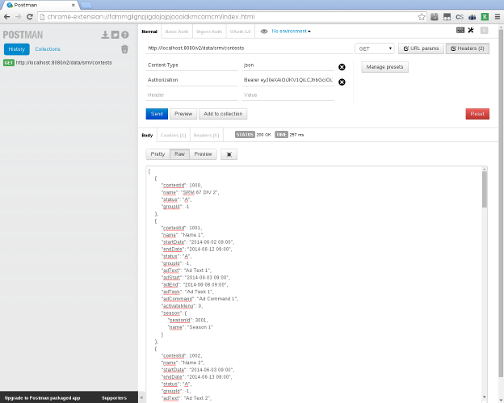

Modify existing Contest using Postman

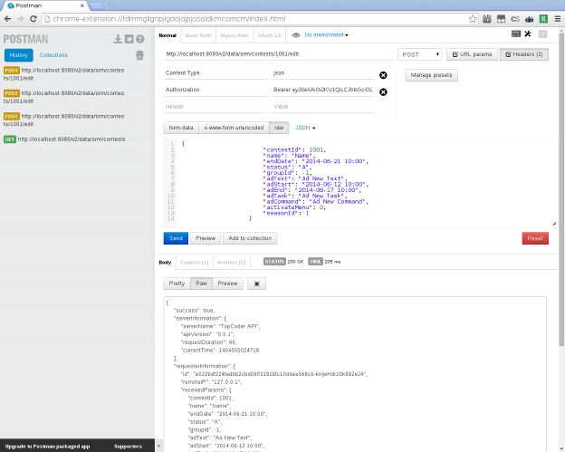
Create contest using Postman

